Fig 1 – Edge Cut = 0.9, Fixed Time = 0.2

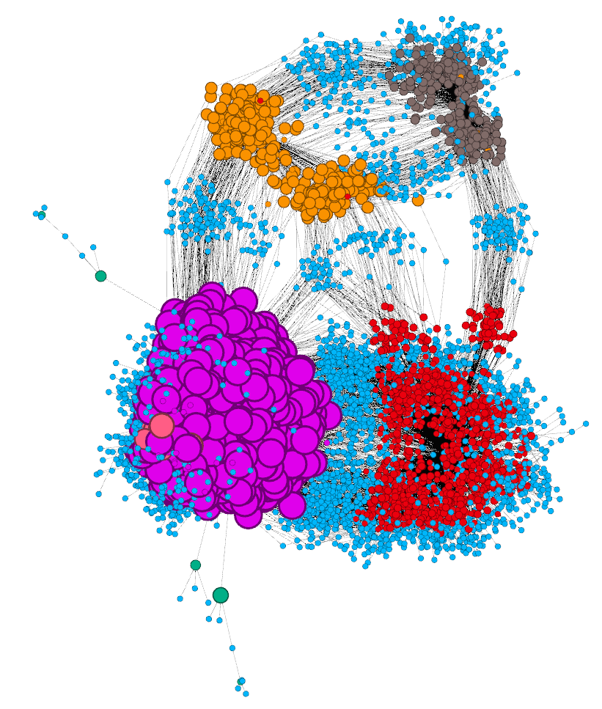

Fig 2 – Edge Cut = 0.9, Fixed Time = 0.1

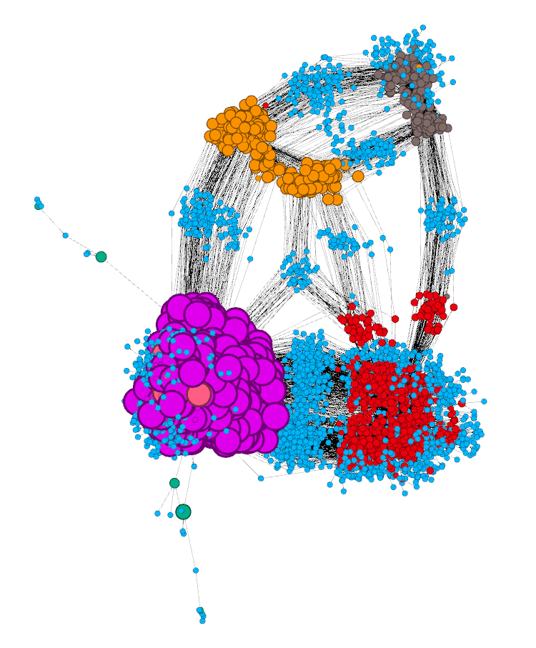

Fig 3 – Edge Cut = 0.9, Fixed Time = 0.9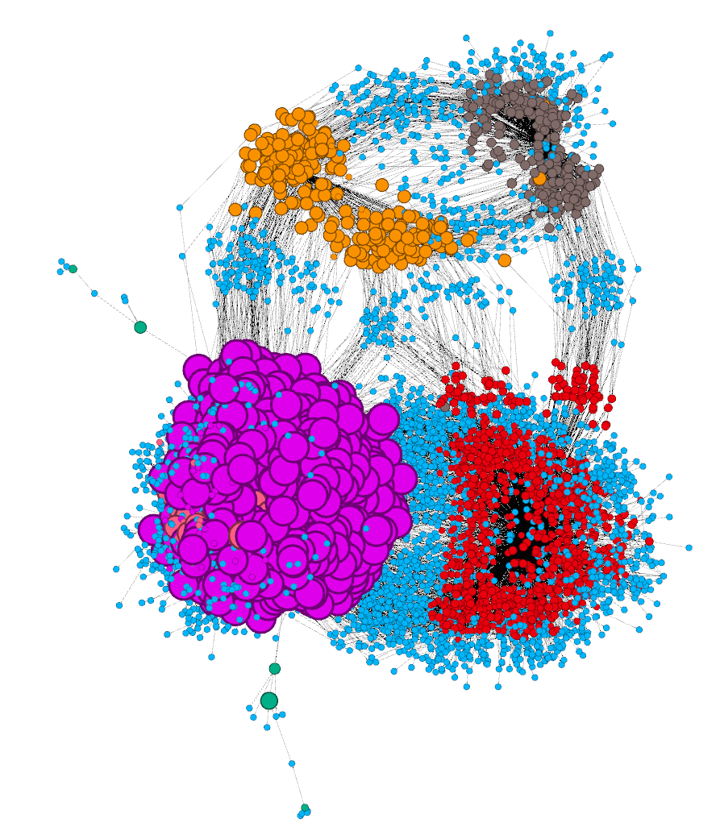

Fig 3 – Edge Cut = 0.9, Fixed Time = 0.2, Num Iterations = 2000 (Expansion = 50%)

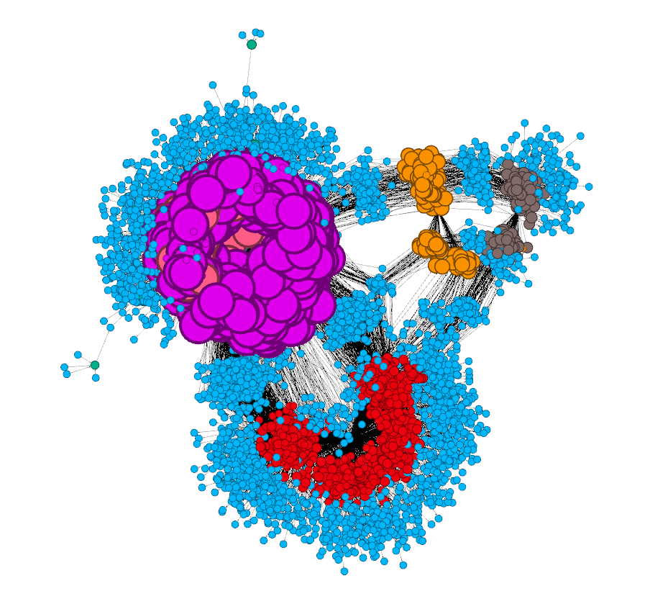

Fig 5 – OpenOrd + Force Atlas

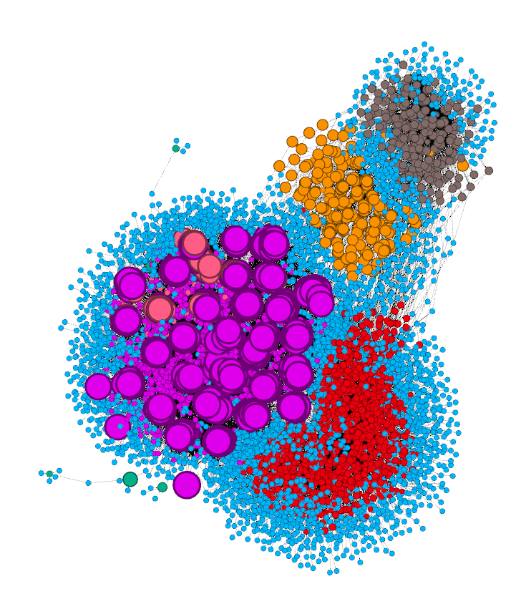

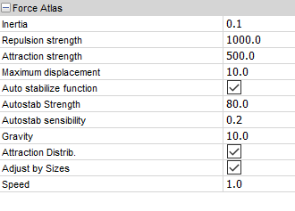

Fig 6 – OpenOrd + Force Atlas

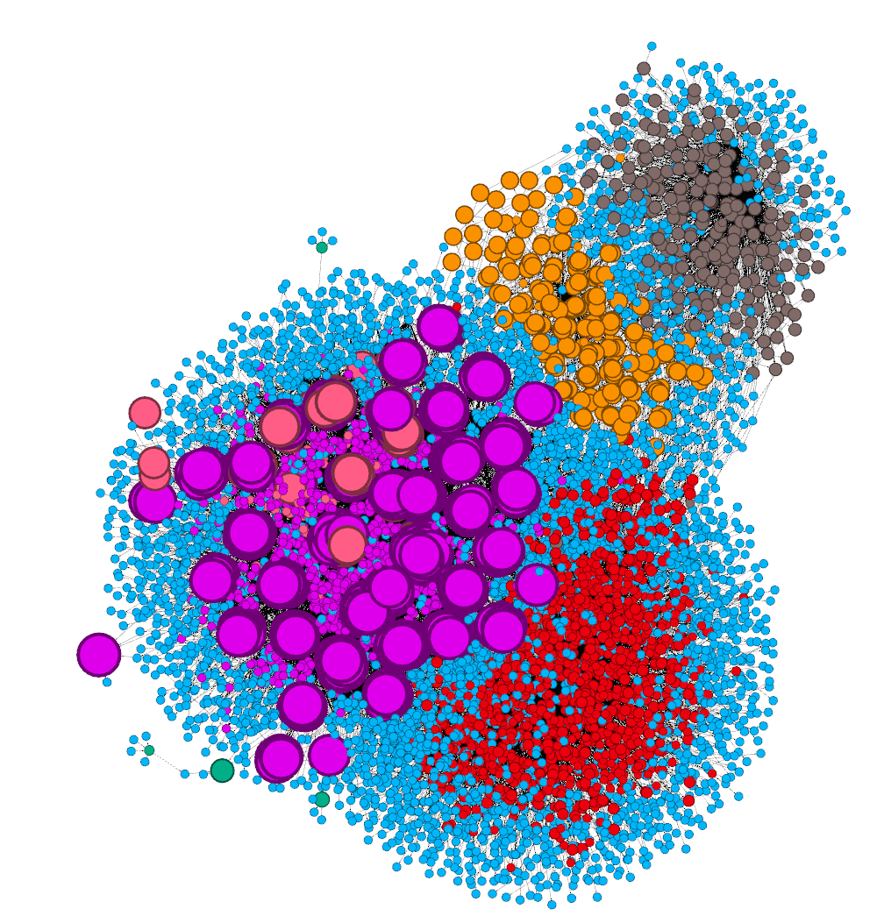

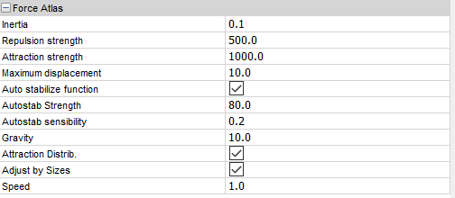

Fig 7 – OpenOrd + ForceAtlas2

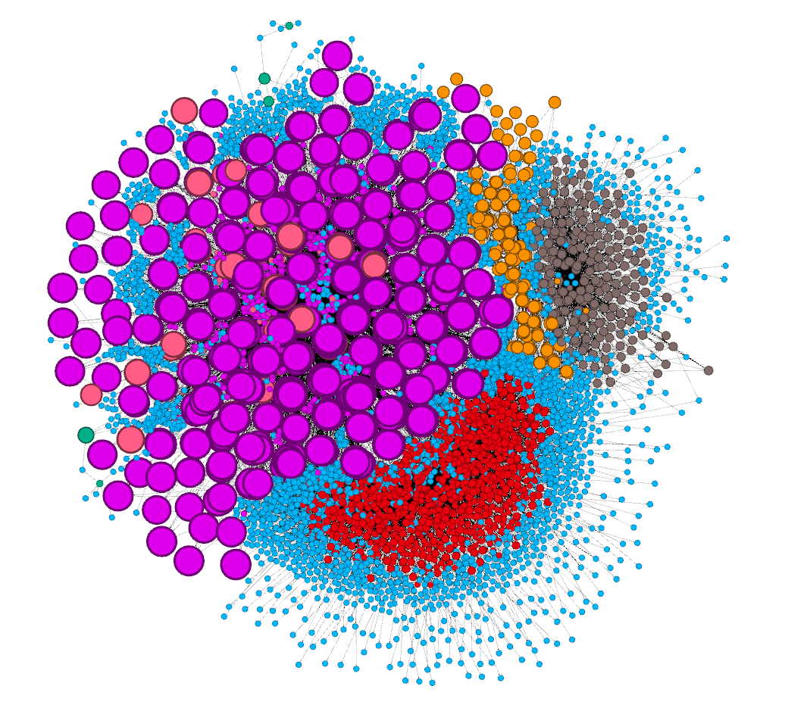

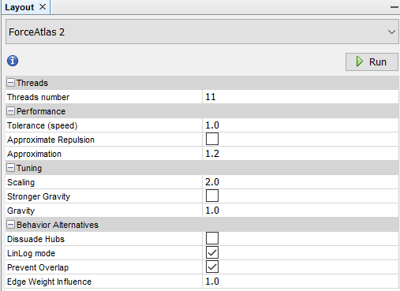

Fig 8 – OpenOrd (longer) + ForceAtlas2

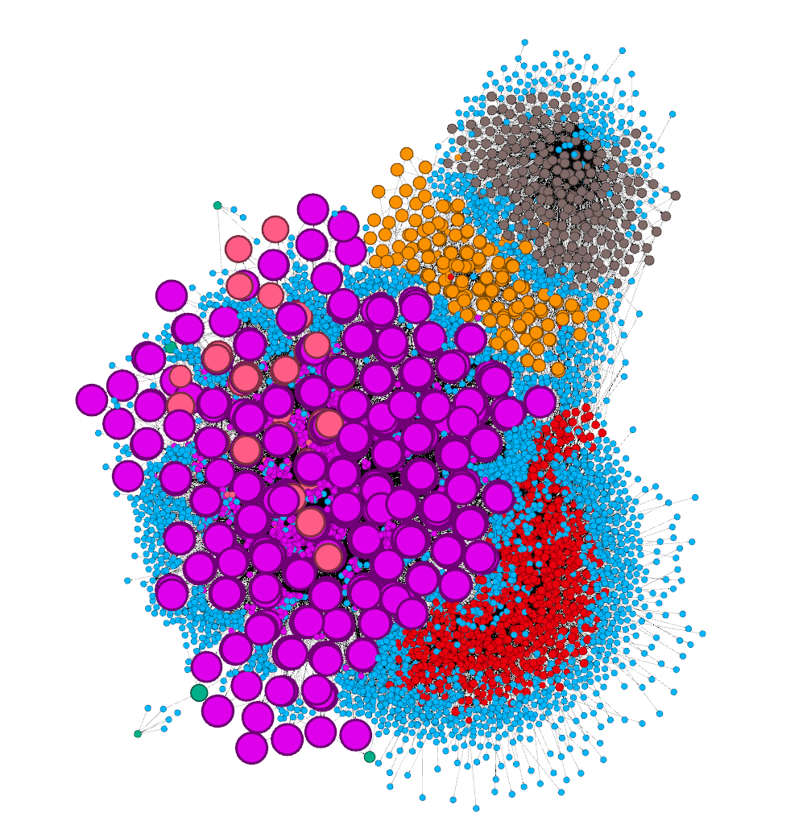

Fig 9 – OpenOrd (longer) + ForceAtlas2 (longer)

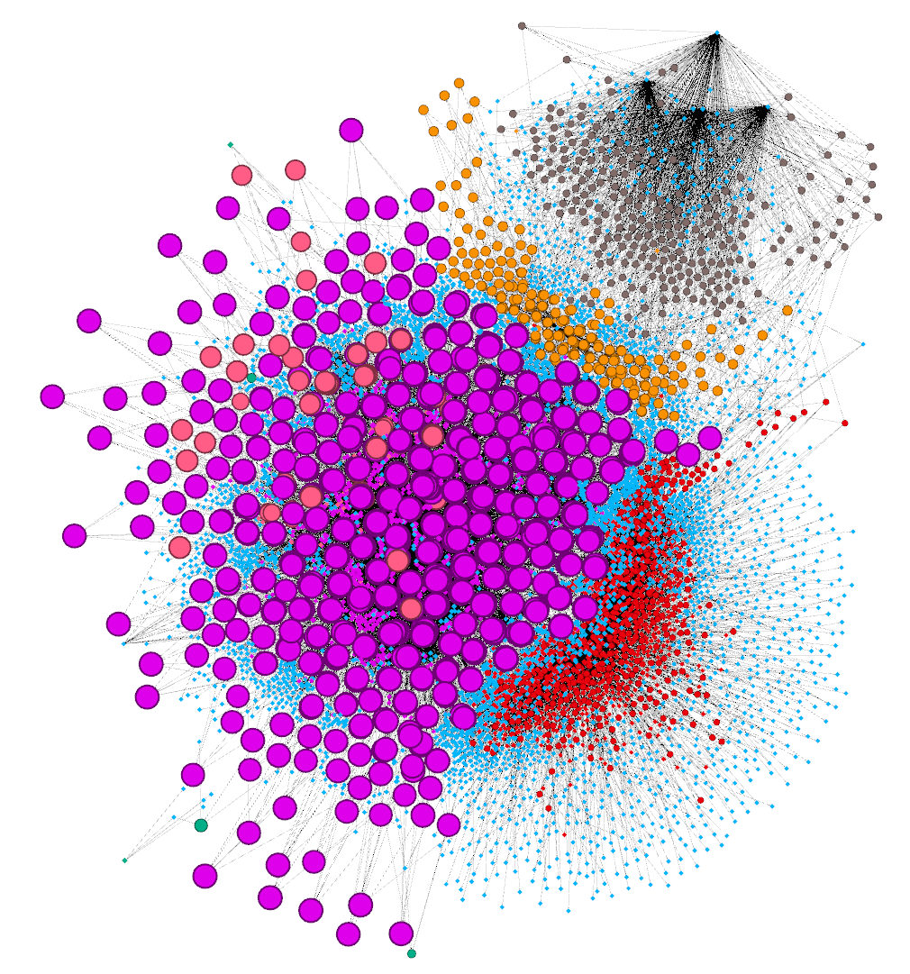

Fig 10 – OpenOrd (long) + ForceAtlas2 (super long)

